CIS 4911 – SENIOR PROJECT

Picture Marketing’s Social Wall

**User’s Manual**

Members: Steve Noel

Mentor: Carlos Ocampo

Instructor: Masoud Sadjadi

**Using the Social Wall Application**

1) Must have a Chrome cast device setup and connected to the desired screen. The setup app can be obtained here <https://cast.google.com/chromecast/setup/> Note. The WIFI network you used to setup the Chrome cast device must also be the same network the mobile device or emulator is connected to.

2) Open the application on the mobile phone or the device emulator. See photo below:

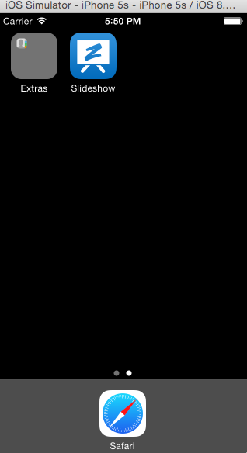

3) Enter your FotoZap credentials in the login screen of the app. If not a fotoZap member you can go here to register <https://manager.fotozap.com/wizard?origin=AppCreateAccount> see below:

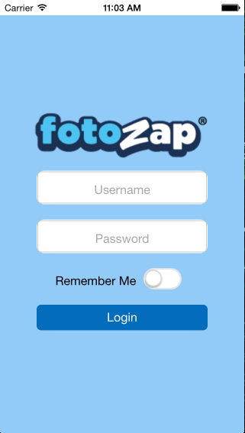

4) Once Logged in select the connect Chrome cast button on the upper right hand of the screen. It will appear if the system detects a Chrome cast device. If you do not see it after 2 minutes then the chrome cast device is not connected properly, set the device up then try again. See image below.



5) Select the Chrome cast device you wish to connect to from the dropdown list that appears. See image below:

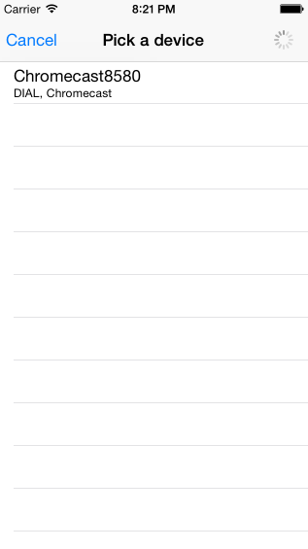

6) Once you select a Chrome cast Device the Chrome cast button will turn blue and the screen connected to the Chrome cast will turn black. If the Chrome cast button turns blue but the desired screen does not turn black please select it again disconnect from the device and reconnect following steps 4 and 5.

7) Select the Campaign from the list to display the images on the desired screen. The selected campaign should have a blue checkmark also a pause button should appear on the bottom of the screen. The Images should be displaying on the desired screen. See image below



8) Select the pause button on the bottom of the screen to play or pause the image slideshow. You can also select any campaign to change the images displaying on the screen.

9) If at any point the pause button on the bottom disappears and the blue checkmark disappears but the Chrome cast button is still blue meaning the device is still connected then press refresh button on the top right hand side of the screen to reconnect the system.